PFC Andrew Martin “Bo” Harper

Bikers, Bros & Bo 2019

It is time for our Sixth Annual PFC Andrew Martin “Bo” Harper Memorial Ride: A ride to honor all fallen heroes. This year is especially special, as it falls on Andrew’s Birthday! We have been able to honor our nations heroes and help local veterans and their families. Bikers, Bros & Bo, Inc., a non-profit organization has been formed to be able to raise money and pay it forward. Our goal each year is to make donations to The Fisher House, Wreaths Across America, Your Community Foundation for local scholarships, Adopt a Veteran Family for Christmas and help a local Veteran in need, but we need your help!

PFC Andrew Martin Harper, 19, of Maidsville, West Virginia, was killed in action on Friday, March 11, 2011 at Kandahar Airfield, Afghanistan. Andrew obtained the rank of PFC/E3 and was assigned to Co I, 3d Squadron, 2d Stryker Cavalry Regiment Vilseck, Germany.

Company Commander Capt. Daniel Bourke remembered PFC Andrew Martin “Bo” Harper as being “one of the finest infantrymen” in Company I. Andrew’s father, Steve reminds others that PFC Andrew Martin “Bo” Harper was not only my son, but my best friend. He was not only a hero to me, but a hero to a nation. A nation that’s indebted to him, for he gave all. Steve has said through tears if I could say one thing to him now, it would be ‘I’m proud of you son and I’ll always miss you’.” Steve Harper has also stated that each year it is hard to relive the memories and feelings, however, this ride helps him get through days of sorrow and missing his son, it is a way to keep his memory alive.

Throughout the past five years of this Memorial Ride, Bikers, Bros & Bo has been able to donate funds raised to an Endowment Fund in Memory of PFC Andrew Martin “Bo” Harper established at Your Community Foundation, Inc. This Fund provides annual scholarships to students of Monongalia and/or Harrison Counties. In addition to providing the scholarship(s), we have been able to make donations to The Fisher House, which is a “home away from home” for Military Families. The Fisher House is best known for a network of comfort homes where families of Military can stay at no cost. Last year, we were able to give out two scholarships, adopt a family for Christmas, make a donation to The Fisher House and raised and donated money to help cover over 1,300 Wreaths at the WV National Cemetery.

Bikers, Bros & Bo in Memory of PFC Andrew Martin “Bo” Harper can only achieve its goals with the assistance of generous donations from members of our community. Without these donations, serving those in our area would not be possible.

Since our organization relies on the generosity of individuals like you, we write to ask you to consider sponsoring or donating items to our cause. Bikers, Bros & Bo, Inc. accepts monetary donations, as well as items for a raffle which is held at the closing ceremonies of the Memorial Ride, scheduled for August 17, 2019. Please use the attached sheet to determine the Sponsorship Tier you wish to contribute. All other donations will be considered a Friend of the Ride and will be included in advertisements for the ride.

We hope that you will support our efforts by sponsoring or donating to our cause.

Sincerely,

BIKERS, BROS & BO
304-692-6015
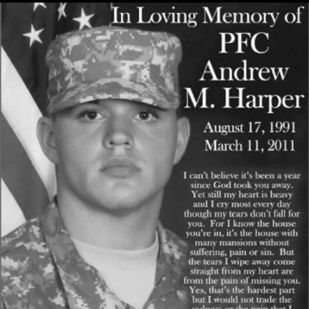
6th Annual
PFC Andrew Martin “Bo” Harper
Memorial Ride

Saturday, August 17, 2019

Thank you for your consideration of being a Sponsor of our Memorial Ride.
PFC Harper gave us his all; let’s join forces to show him we will forever be grateful.

Please fill out this form and return with donation to: Checks Payable to:
Bikers, Bros & Bo, Inc. Bikers, Bros & Bo
P. O. Box 391 Memo:PFC Harper
Dellslow, WV 26531

All sponsorships are to be returned by
June 1, 2019

_______GOLD SPONSOR ($500+)
- Recognition on print advertisements
- Radio interview during event live remote
- Business Name on Event T-Shirt
- Logo on Bikers, Bros and Bo website
- Recognition on Bikers Bros and Bo Social Media
_______SILVER SPONSOR ($250-$499)
- Recognition on event t-shirts
- Recognition on print advertisements
- Recognition on Bikers, Bros & Bo Social Media and website
- Recognition on event print advertisements and signage
_______BRONZE SPONSOR ($150-$249)
- Recognition on print advertisements
- Recognition on event t-shirts
- Recognition on Bikers, Bros & Bo website
_______FRIEND OF THE RIDE ($100- $149)
- Recognition at final stop
- Recognition on Bikers, Bros & Bo Social Media

Name/Company: _____________________________________________________________

Address: ________________________________________________________________________

Email: ____________________________________________________________________________

Amount and/or Items: _________________________________________________________

Sponsors: Please list name as you would like it to appear on fliers, t-shirts and other advertisements for the Bikers, Bros & Bo 2019:

